Dear friends and supporters of Trätro! February 7, 2026

We would like to express our sincere gratitude for all your support over the past year and we are very thankful for what we have been able to do for the poorest with God's help (see attachment).

We would also like to thank you for all the emergency aid you have entrusted us with!

The enormous masses of water that displaced 300,000 people are receding and some are already able to return to their homes.
AVA is no longer housing refugees, but we are supplying other refugee homes with the necessities.
To this end, our friends at the aid organization ORA in Andorf/Upper Austria are financing a new used truck for us, for which we are very grateful!
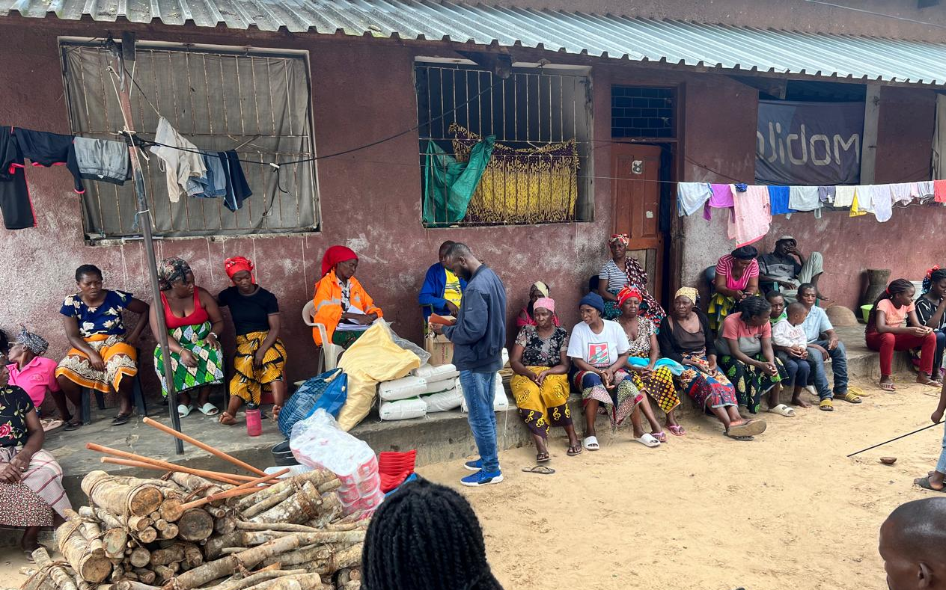

We also have to renovate our buildings, as the rainwater has soaked many walls, including in our guest house, where I will be moving back in next week.
New (or first) plastering is in progress, and additional protective roofs are to be installed.

My flight leaves next Tuesday, and I will no longer wait in Austria for my missionary visa, nor for the money from the sale of the house.... Ten weeks are enough!
In the meantime, our container has arrived and cleared customs, and our car is still on its way. Heinz has a lot of bureaucracy to deal with, and a new management structure for EMCA is also being worked on.

I can take all donations for flood victims or other aid projects received by Tuesday with me in cash, which saves on transfer costs.
Thank you all so much for your support!!! 😊
Let us also pray for protection from further cyclones and heavy rain, as the rainy season is not yet over!

Warm regards and God's blessings! 😊

Sabine Appel-Mohrs
https://www.traetro.at/
TräTro - Tränen trocknen in Afrika e.V.
(this is the exact account name for the bank's new verification system)
Trätro account: IBAN: AT574480010653130001 BIC: VBOEATWWOOE
Charity seal of approval since 2015, donations tax-deductible

Translated with DeepL.com (free version)

Translated with DeepL.com (free version)

